Smart Seat

Details Design V0.9

**Group members：**Hanyu Zhang, Tinghui Zhang, Huiying Han, Yikang Tao

目录

Smart Seat 1

1 引言 4

1.1 编写目的 4

1.2 背景 4

1.3 定义 4

1.4 参考文献 5

1.5 标准、条件和约定 5

2. 总体设计 6

2.1 项目目标 6

2.2 需求概述 6

2.3 软件结构 7

2.4 项目开发环境 7

2.5 详细设计方法和工具 8

2.5.1 E-R图 8

2.5.2 程序流程图 8

3 系统详细需求分析 10

3.1 详细功能需求分析 10

3.2 详细功能描述 10

3.2.1 注册登录模块 10

3.2.2 座位预定模块 10

3.2.3 座位报修模块 10

3.2.4 座位信息查询模块 10

3.2.5 个人信息查询模块 11

3.2.6 管理员信箱模块 11

3.2.7 PIR传感器远程监测座位模块 11

3.2.8 Socket通信远程访问指示灯模块 11

3.3 接口设计 11

3.3.1 用户接口 11

3.3.2 外部接口 11

4 数据库设计 12

4.1 用户表 12

4.2 管理员表 12

4.3 座位表 12

4.4 报修表 12

# 1 Introduction

## 1.1 Purpose of writing

The purpose is to:

* Provide evidence for the coders；
* Provide conditions for modification and maintenance；
* The project leader will arrange and control the whole process of development work as required by the plan；
* The project quality assurance personnel will perform phased and summarizing quality verification and confirmation according to this plan.

The tone readers of this manual include：

* project developers, especially coding staff；
* Software maintenance personnel；
* technical management personnel；
* Participate in the verification, confirmation and relevant personnel responsible for the final report acceptance and appraisal of the project.

## 1.2 Background

At present, there are many seats in major university libraries, but there are still a large number of seats in short supply during the peak period of use. Occasionally, individual students may experience unpleasantness due to occupying behavior. Many students will also find a place to study and read a lot of time after a long search in the library, which greatly reduces the enthusiasm of the students.

At present, the library equipment is perfect, but the repair is not timely. It often happens that although there is a location, it is not properly used due to the damage of the hardware facilities.

The project's entrusting unit, development unit and competent department:

Entrusted by: Software Project Management Course, School of Information Engineering, Shanghai Maritime University

Development unit: the eighth group

Competent department: School of Information Engineering, Shanghai Maritime University

## 1.3 Definition

Terminology:

**PIR:** pyroelectric infrared sensor

**NodeMcu:** An open source IoT platform

**MySQL:** The database relational system (DBMS) used by the system server.

**SQL:** A language for accessing the query database

**Transaction flow:** There may be multiple paths to process after the data enters the module.

**SQL:** Structured Query Language.

**UML:** Unified Modeling Language, a set of standard modeling languages for designing software blueprints, is a standardized modeling language from software analysis and design to programming specification.

## 1.4 Reference

《Software project management》Rajeev T Shandilya Science press

《UML and pattern applications》Craig Larman Machinery industry press

National standards document for software engineering

## 1.5 Standards、conditions and conventions

The project follows the following standards:

**GB/T** computer software classification and code

**GB/T** information technology

**GB/T** software engineering

**GB/T** software engineering standard taxonomy

**GB/T** computer test documentation

**GB/T** computer software requirements specification

**GB/T** computer software testing specifications

**GB/T** information technology programming language

**GB/T** information technology software engineering

**GB/T** computer software documentation specifications

# 2. Overall design

## 2.1 Project Objectives

* Designing an intelligent occupancy system sample based on the Internet of Things.
* Develop a smart occupancy background management system that can be put into use.

## 2.2 Overview of requirements

（1）System administrator requirements：

1. Managing seat conditions
2. Check the repair information
3. Manage user information

（2）User requirements：

1. Login
2. Register
3. Seat reservation
4. Repair
5. Search for seat information
6. View personal information

（3）Intelligent device networking：

1. PIR sensor detection information
2. NodeMcu platform uploads received data via WiFi
3. The web receives feedback and clicks on the light

## 2.3 Software structure

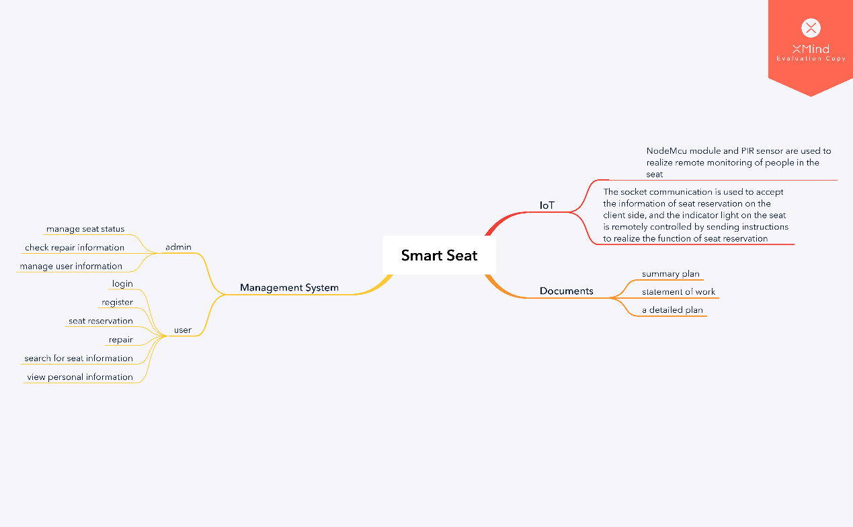Figure2-1 Software detailed structure diagram 1

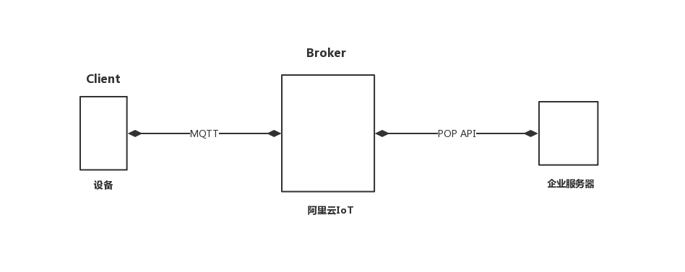

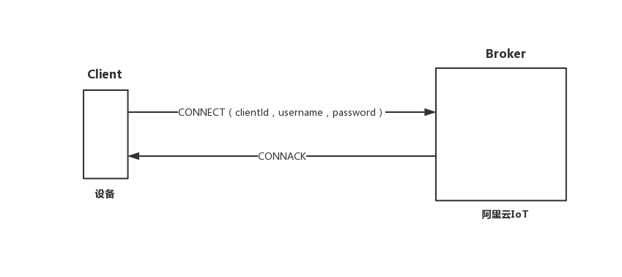Figure2-2 Software detailed structure diagram 2

Figure2-3 Software detailed structure diagram 3

## 2.4 Project development environment

Support conditions needed during development:

Hardware:

* Server: Pentium III above 500 or higher
* RAM：over 128M
* ROM：at least 10G above

Software:

* The operating system is Windows 8 or above, and the integrated development tools Arduino IDE and PyCharm are used. MySQL is used as the database, and the project running environment is apache2.4.

## 2.5 Detailed design methods and tools

### 2.5.1 E-R diagram

The E-R diagram, also known as the Entity Relationship Diagram, provides methods for representing entity types, attributes, and connections to describe real-world conceptual models.

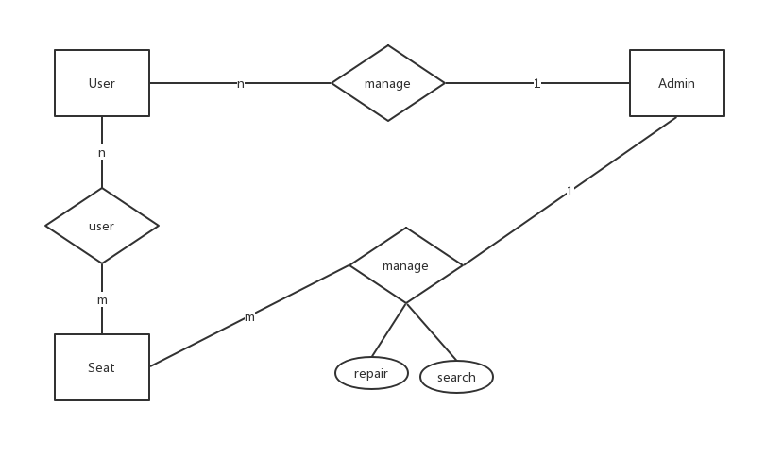It is an effective way to describe the conceptual model of real world relations. Is a way of representing a conceptual relationship model. Use "rectangular box" to represent the entity type, the rectangle box to indicate the entity name; use "ellipse frame" to represent the attribute of the entity, and use "solid line segment" to connect it with the "physical type" of the corresponding relationship;

Figure2-4 E-R diagram

### 2.5.2 Program flow chart

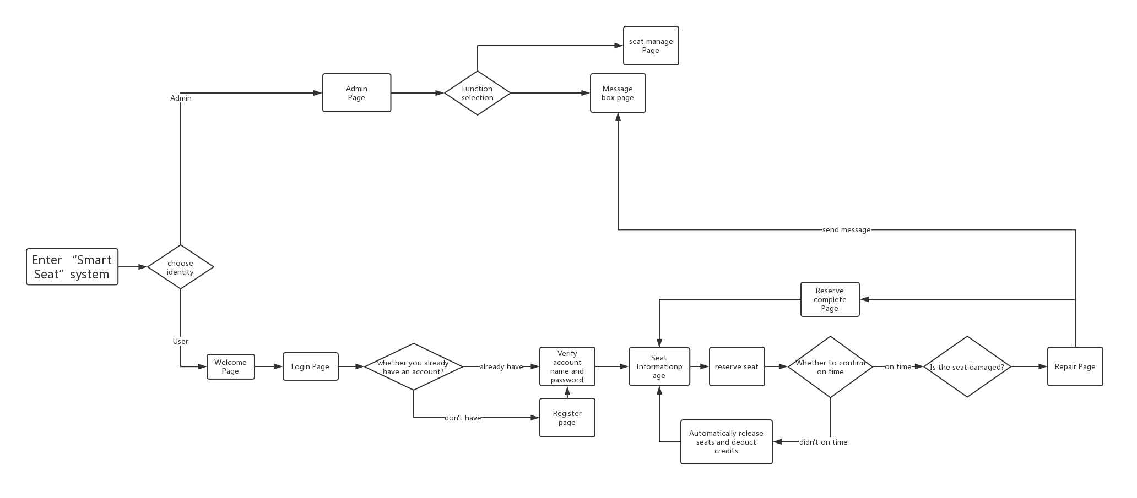The program flow diagram, also called the block diagram, is a graphical representation of the specific steps of the program running with the standard symbols specified. The block diagram is designed based on the processing flow chart, through the detailed analysis of the input and output data and processing, the main operating steps and content of the computer are identified. The block diagram is the most basic basis for programming, so its quality is directly related to the quality of programming.

Figure2-5 Program flow chart

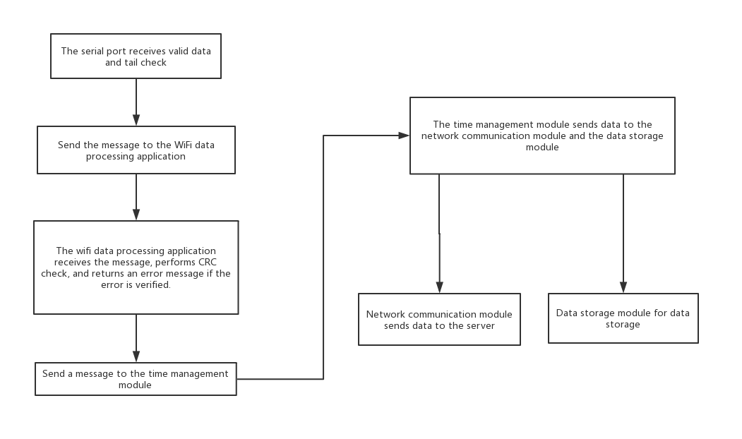

Figure2-6 IoT module flow chart

# 3 System detailed requirements analysis

## 3.1 Detailed functional requirements analysis

This system has the following function modules:

1. Register the login module
2. Seat reservation module
3. Seat repair module
4. Seat information inquiry module
5. Personal Information Query Module
6. Administrator Mailbox Module
7. PIR sensor remote monitoring seat module
8. Socket communication remote access indicator module

## 3.2 Detailed function description

### 3.2.1 Registration & Login module

It is divided into normal user login and administrator login. The administrator account is unique and does not need to be registered. Ordinary users can only use all the functions of this system only after they have registered an account and logged in.

### 3.2.2 Seat reservation module

It is only restricted to ordinary users. When the credit value of the ordinary user is higher than the critical value, the seat reservation function can be used normally. The seat can be reserved by inquiry. After the user selects the reservation, the user is prompted to successfully reserve the seat. The seat is reached within the specified time and manually confirmed. Successfully booked once. If the predetermined seat is not confirmed manually within the specified time, the system will automatically release the seat and deduct the user credit value.

### 3.2.3 Seat repair module

Only for ordinary user operations, after the ordinary user successfully makes a reservation, the user can choose to enter the repair page, and after inputting relevant repair information, the repair information will be automatically sent to the administrator mailbox, and the administrator will receive the repair information for related processing.

### 3.2.4 Seat information inquiry module

Only for ordinary user operations, ordinary users can view all seat statuses in the current library and make seat reservations by finding free positions.

### 3.2.5 Personal information inquiry module

Both normal users and administrators can operate. Ordinary users can view their current information and current credit values. Administrators can view and modify user related information.

### 3.2.6 Administrator mailbox module

For administrator operations only, the administrator can open the mailbox to view the current seat repair information or suggestions for the system.

### 3.2.7 PIR sensor remote monitoring seat module

Remotely monitor the seat with the NodeMcu module and the PIR sensor. If the seat is currently unoccupied and the seat is not reserved, it will be released as idle.

### 3.2.8 Socket communication remote access indicator module

The socket communication is used to receive the client seat reservation information, and the indicator light on the seat is remotely controlled by sending an instruction. If the user successfully booked the seat but has not confirmed it, the indicator light on the desk lights up, indicating that the person who has not used the system has been occupied.

## 3.3 Interface design

### 3.3.1 User interface

Provide users and administrators with an easy-to-use UI and help documentation.

The login page is popped up first, and the user identity is selected for the user to enter a username and password. After the login is successful, you can choose to enter the seat reservation interface. After the reservation is successful, you can select the repair page.

After the administrator logs in successfully, you can choose to enter the seat management page and the administrator mailbox page.

### 3.3.2 External interface

Use components and technologies based on the right open standards to ensure maximum collaboration and ease of integration with third-party systems and components. Such standards include but are not limited to the following：

* Network protocols and standards（TCP/IP、HTTP、SSL、etc）
* Language（Python、C、SQL、etc）
* Database connectivity（ADO.net）

# 4 Database Design

## 4.1 User

|  |  |  |
| --- | --- | --- |
| **User** | | |
| **Name** | **Type** | **Note** |
| UserId | Int | Key |
| Username | Varchar255 |  |
| Password | Varchar255 |  |
| Name | Varchar255 |  |
| Sex | Varchar255 |  |
| Image | Varchar255 |  |
| Birthday | Varchar255 |  |
| Credit value | Int |  |

## 4.2 Admin

|  |  |  |
| --- | --- | --- |
| **Admin** | | |
| **Name** | **Type** | **Note** |
| AdminId | Int | Key |
| Username | Varchar255 |  |
| Password | Varchar255 |  |

## 4.3 Seat

|  |  |  |
| --- | --- | --- |
| **Seat** | | |
| **Name** | **Type** | **Note** |
| SeatId | Int | Key |
| Area | Varchar255 |  |
| Status | Varchar255 | 0-Free，1-Reserving，2-Using |
| Repair | Boolean | 0-intact,1-broken |

## 4.4 Repair

|  |  |  |
| --- | --- | --- |
| **Repair** | | |
| **Name** | **Type** | **Note** |
| RepairtId | Int | Key |
| SeatId | Int |  |
| UserId | Int |  |
| ReportDate | Varchar255 |  |
| CompleteDate | Varchar255 |  |
| Information | Varchar255 |  |

# 5 System error handling design

## 5.1 System error remedy

Possible workarounds after a failure, including:

a. Backup technology: The backup technology used, when the original system data is lost, the establishment and startup of the enabled copy, such as periodically recording the disk information to the tape is a backup technology for the disk media;

b. Fallback technology: The backup technology used, using another less efficient system or method to obtain some parts of the desired results, such as the automatic system's fallback technology can be manual operation and manual recording of data;

c. Recovery and Restart Technology: The recovery restart technology that will be used to resume software from a point of failure or to re-run the software from the beginning.

## 5.2 System maintenance design

Arrangements made in the internal design of the program for the convenience of system maintenance, including inspection points and dedicated modules specially arranged for inspection and maintenance of the system in the program.